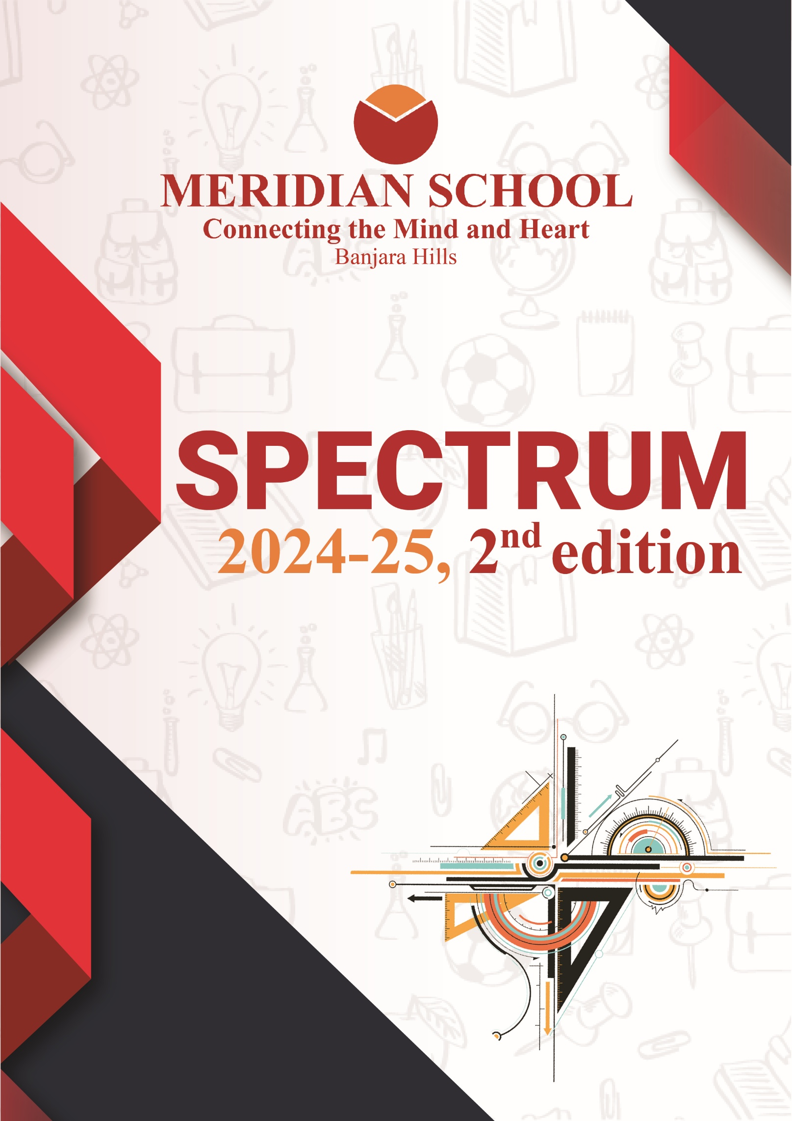

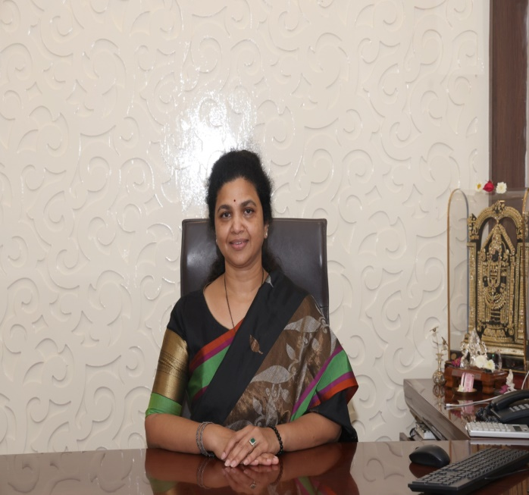
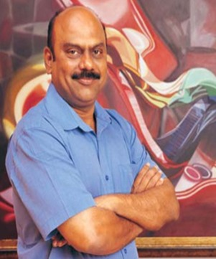

THE FOUNDERS OF THE MERIDIAN GROUP OF SCHOOLS
MR. NEELAKANTA BUTTA
MRS. RENUKA BUTTA
A MESSAGE
Dear Students, Parents, and Faculty,
As we look ahead to another wonderful chapter in the life of our school, I am filled with immense pride and gratitude for the journey we have taken together. From the day we laid the foundation of this institution, our mission has always been to create a nurturing environment where every child is empowered to reach their full potential, both academically and personally.
Education is a powerful tool, not only for knowledge but for shaping the future of our society. It is our duty to provide students with the skills, values, and confidence they need to thrive in a rapidly changing world. I am incredibly proud of how our school has upheld these values and continues to be a beacon of excellence, creativity, and inclusivity.
To our dedicated staff, I am deeply thankful for your relentless efforts in creating a stimulating and supportive environment for our students. Your passion for education and your commitment to shaping young minds is truly inspiring.
To the parents and guardians, thank you for your trust in us and for being a crucial part of this community. Your involvement is key to our students’ success, and together we can continue to guide them toward brighter futures.
Lastly, to our dear students: always remember that learning is a lifelong journey. Embrace every opportunity, challenge yourselves, and be proud of every step you take toward your dreams. You are the heart and soul of this institution, and I look forward to seeing all that you will achieve in the years to come.
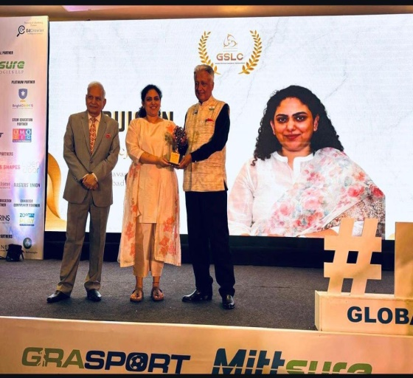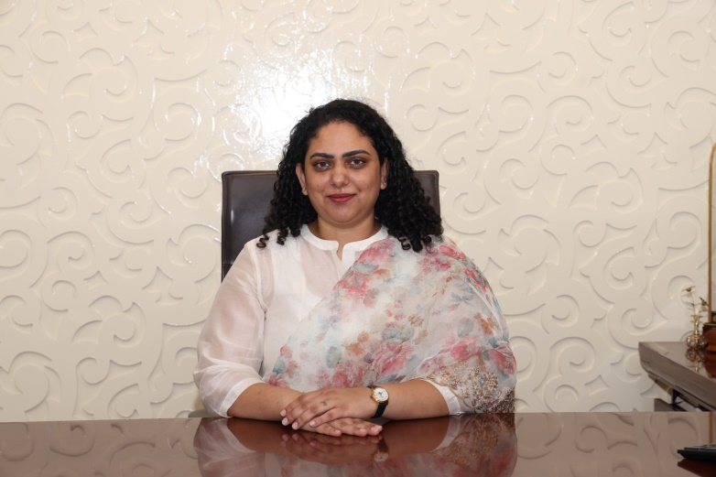

CEO OF THE MERIDIAN GROUP OF SCHOOLS
MS. TEJASWI BUTTA
Dear Students, Parents, and Faculty,
It is my privilege to share a few thoughts as we continue our journey of growth and excellence. Our school was founded on the principles of providing world-class education that nurtures not just academic success but also personal development and global citizenship. I am proud to say that we continue to uphold and strengthen these values year after year.
This year, we are focused on expanding opportunities for our students—introducing new technologies, innovative teaching methods, and programs that encourage critical thinking and creativity. Our goal is to prepare every student to face the challenges of tomorrow with confidence and resilience.
I want to take a moment to thank our dedicated teachers and staff, who work tirelessly to create a positive and enriching environment for our students. Their passion for education and commitment to excellence are the cornerstones of our success.
To the parents, thank you for your trust and partnership in this journey. Your involvement plays a key role in ensuring the success of your children, and we deeply appreciate the strong sense of community that you help to build.
Finally, to our students, you are the heart of our school. Keep pushing your limits, stay curious, and never stop learning. We are here to support you in every step of your journey towards becoming leaders and changemakers.
I look forward to another year of achievements and success, and I am excited about the future we are building together.

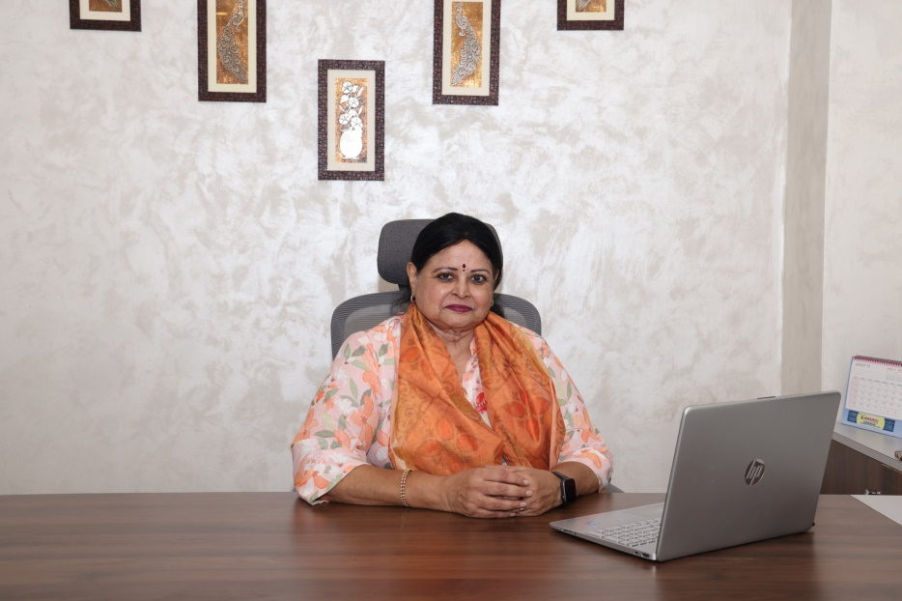

THE PRESIDENT OF THE MERIDIAN EDUCATION SOCIETY
MS. LALITHA NAIDU
Dear Students, Faculty, and Esteemed Members of the School Community,
It is with great pride and enthusiasm that I address you as the President of the Meridian Education Society for this academic year. Our society has always stood as a pillar of growth, creativity, and collaboration, and I am honoured to carry forward its legacy.
This year, we have set ambitious goals to further enrich the student experience, foster leadership, and encourage innovation. We are committed to creating platforms for students to express their talents, engage in meaningful projects, and develop the skills necessary for success, both within and beyond the classroom.
Our society’s strength lies in the collective efforts of its members, and I am confident that, together, we will continue to achieve great things. I encourage all students to get involved in the events and initiatives we have planned, as these opportunities not only enhance your learning experience but also help you build lasting friendships and invaluable networks.
A heartfelt thank you to our advisors, teachers, and fellow society members who have supported us in every step of our journey. I look forward to working closely with all of you to make this year one of the most memorable and impactful for our school community.
Together, let’s make this year one filled with creativity, collaboration, and achievement.
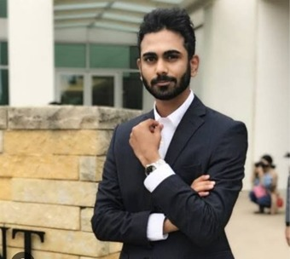

COO OF THE MERIDIAN GROUP OF SCHOOLS
MR. AMOGH BUTTA
Dear Meridian School, Banjara Hills
I’m thrilled to share a message with all of you at this exciting time in our school’s journey. Being part of such an energetic and forward-thinking community is a privilege, and as someone passionate about education and innovation, I’m eager to see how we can continue to grow together.
Our vision is to blend tradition with modern approaches, ensuring that every student has access to cutting-edge resources while still cherishing the values that make us a close-knit school community. As we implement new technologies, enhance our facilities, and expand extracurricular opportunities, my goal is to ensure that every step we take is in the best interest of our students’ growth and well-being.
To our students, I encourage you to embrace every challenge and make the most of the opportunities you’re given. The future is yours, and I believe in your ability to shape it. Be bold, be creative, and don’t be afraid to push boundaries.
To the parents, thank you for your trust and support. Your involvement and feedback are invaluable, and I look forward to continuing our partnership to create the best possible experience for our students.
Lastly, a special thank you to the staff and faculty, whose dedication and hard work ensure the smooth running of our school and the holistic development of every child.
I’m excited about what lies ahead and am confident that together, we’ll continue to make Meridian an incredible place for learning and growth.

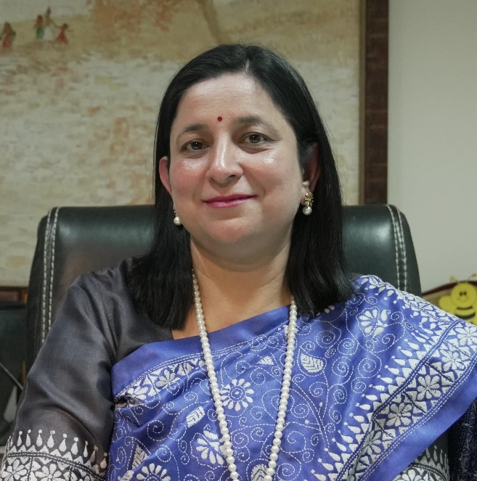

FROM THE PRINCIPAL’S DESK
MS. NISHI RANA
Dear Readers!
At Meridian School, we believe that education goes beyond textbooks. Our mission is to nurture the holistic development of every student, helping them grow into confident, compassionate, and responsible global citizens.
We take pride in fostering an environment where academic excellence is paired with values like empathy, resilience, and respect. Our talented faculty is committed to providing innovative and engaging learning experiences, ensuring that each student is equipped with the skills and knowledge to thrive in a rapidly changing world.
In addition to a strong academic foundation, we offer a wide range of extracurricular activities that encourage students to explore their passions, whether in sports, arts, technology, or community service. We are also proud of the partnerships we build with families to support the growth of our students and help them become lifelong learners.
At Meridian School, we are not just shaping the minds of today—we are inspiring the leaders of tomorrow.
Thank you for your cooperation, and we look forward to welcoming you to our school community.

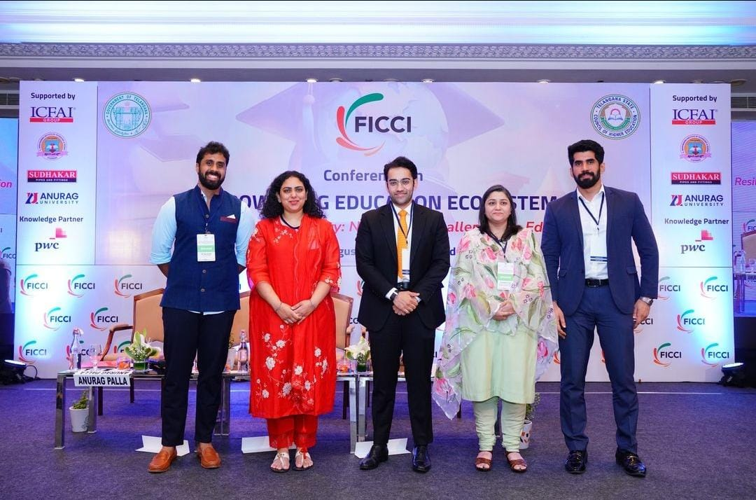
PROUD OF OUR CEO!

Ms. Tejaswi Butta, the CEO of Meridian Schools, was honoured to be a panellist at the FICCI event on Empowering Education Systems, where she emphasized the need for creating resilient learning environments.

Congratulations!
The Meridian family is proud of your many achievements!

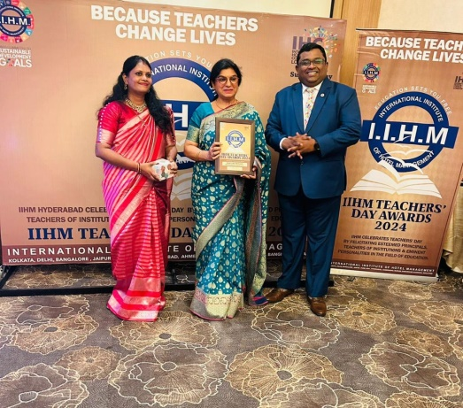
Vice Principal, Meridian Banjara, Ms. RAHAT RASHED wins her 3rd BEST TEACHER AWARD . CONGRATULATIONS MA’AM!
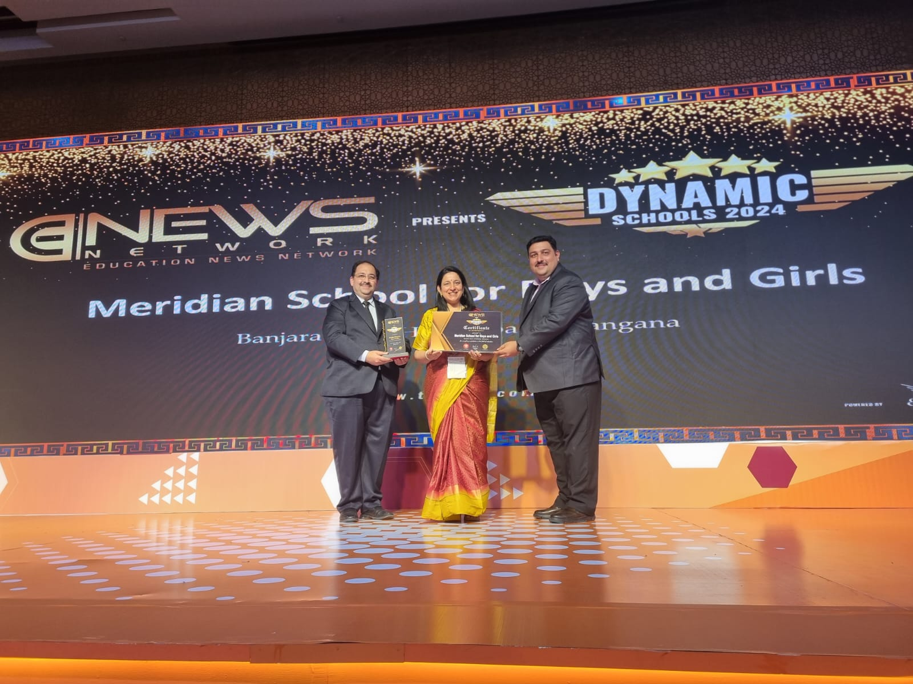

HEARTY CONGRATULATIONS TO PRINCIPAL MADAM NISHI RANA
FOR BEING AWARDED
THE MOST DYNAMIC SCHOOL AWARD 2024
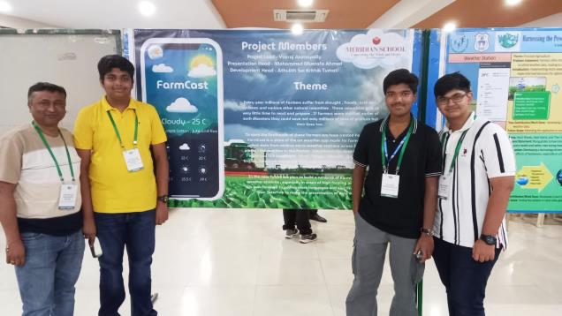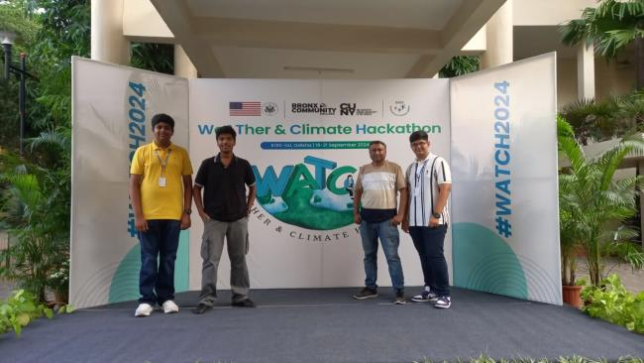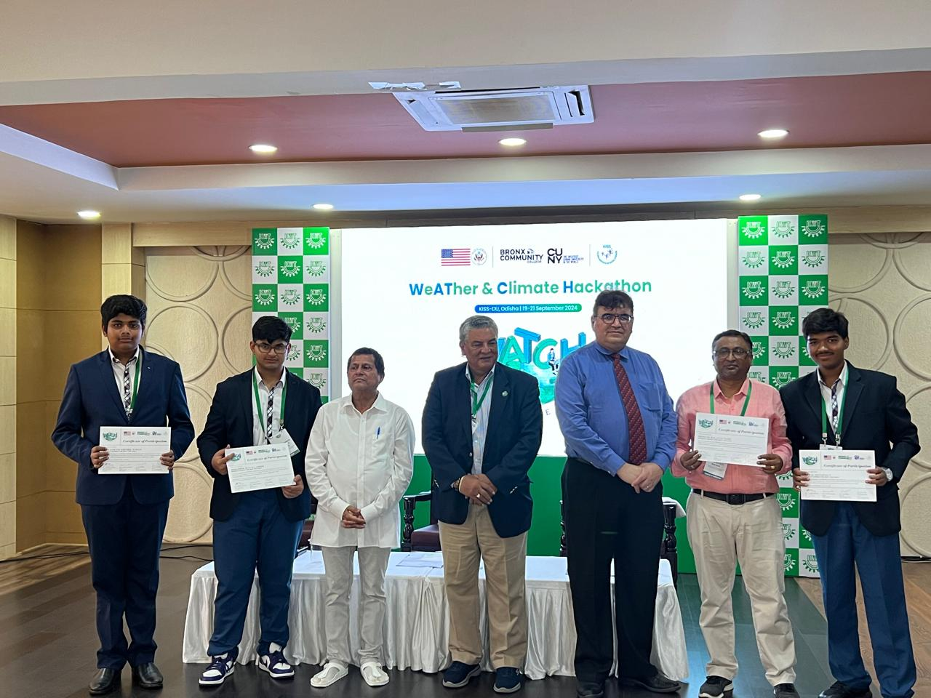
CLIMATE CHANGE CONQUERORS!

Heartiest Congratulations to our WATCH HACKATHON Team for winning a cash award of 150 US dollars
Mr Neal Phillip from City University of New York personally expressed his appreciation of our team.
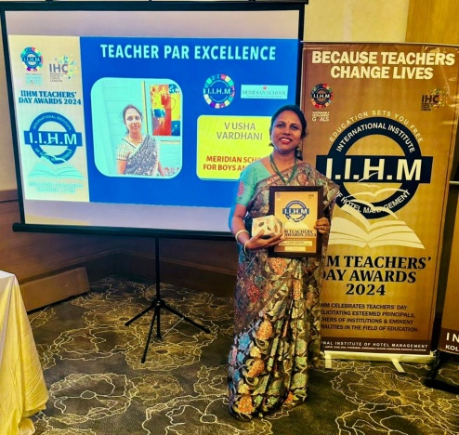
CONGRATULATIONS
Ms. USHA VARDHINI , Middle School Math Teacher for
Winning the BEST TEACHER AWARD

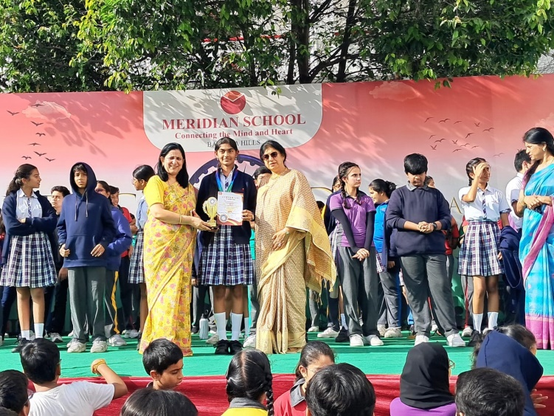
Congratulations on being selected for the final round of Spell Bee!
The Spell Bee competition is an exciting event that tests participants' spelling skills, vocabulary, and quick thinking. Students compete by spelling words of increasing difficulty, showcasing their linguistic abilities. The event fosters a love for language and encourages academic excellence. It's a fun and challenging experience that boosts confidence and sharpens the mind.

Congratulations Winners Of the Final Round – SPELL BEE INDIA
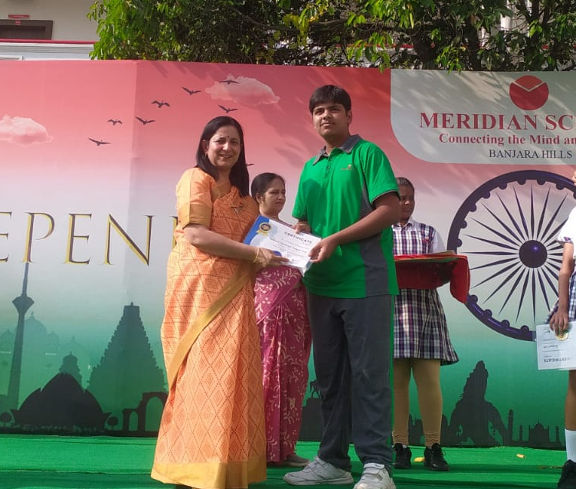
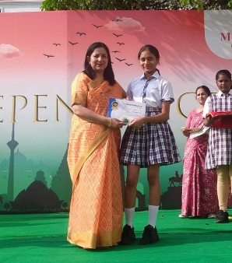

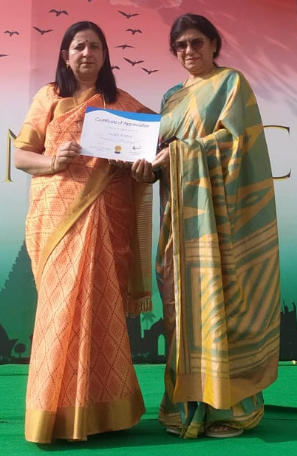
Hemanth Goud 9E Vrithi Bodakunti 8A
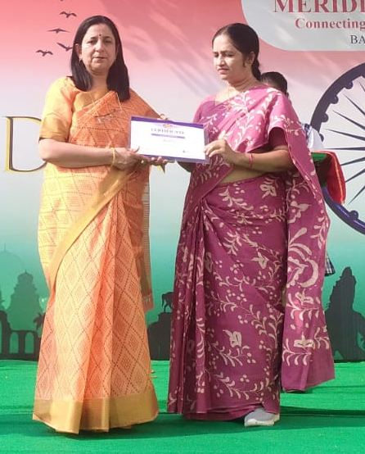

Ms. Mallika Bilquis Fathima
Coordinator SPELL BEE

Congratulations winner of the Ranga Reddy district level Gymnastics Competition
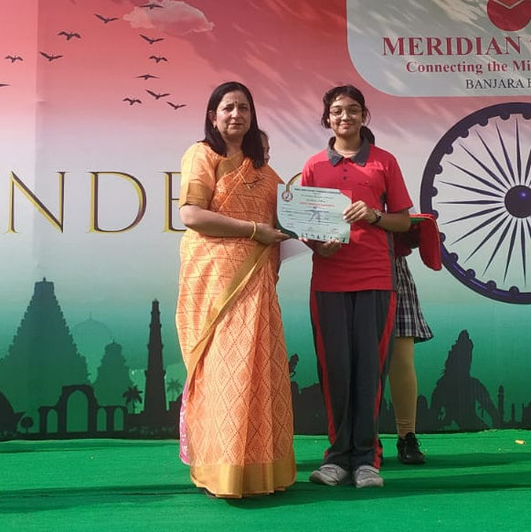

Drithi Ambatipudi 7C SILVER MEDAL

SENSATIONAL SUCCESS!

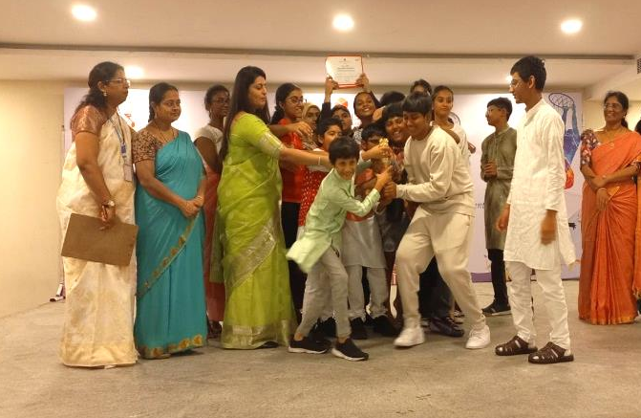

CONGRATULATIONS MERIDIAN BANJARA!

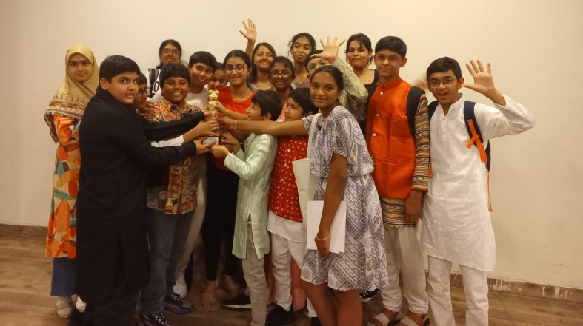

Meridian School, Kukatpally, organised the Meridian Mock Parliament and
Meridian School, Banjara Hills, won the First Prize !

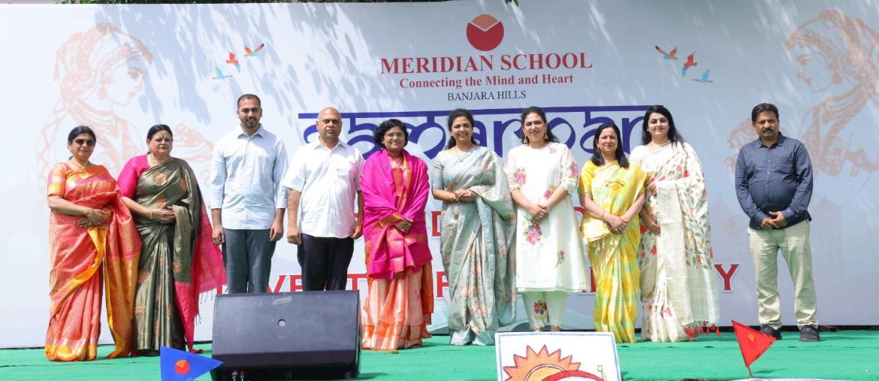
29th Founders’ Day and Investiture Ceremony

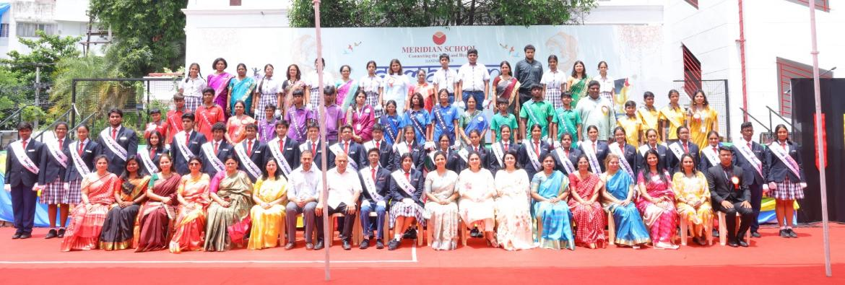
TEAM MERIDIAN! BANJARA HILLS

THE MERIDIAN BANJARA CABINET 2024-25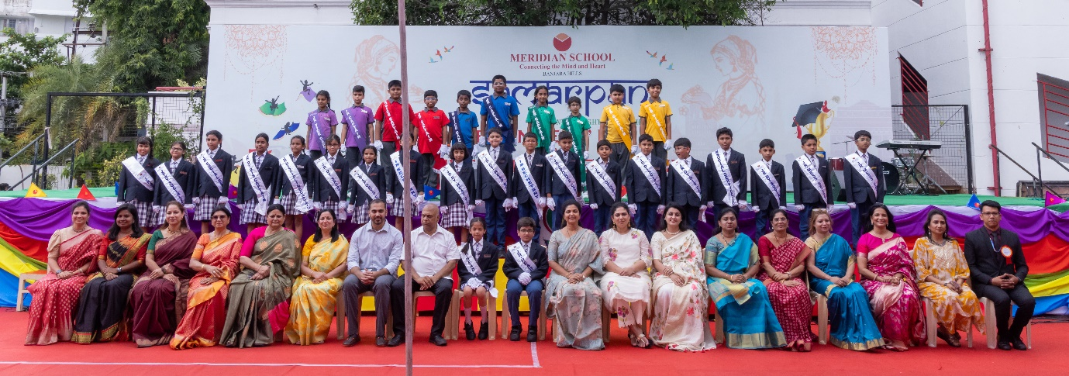
THE MERIDIAN BANJARA CABINET 2024-25
Meridian School for Boys and Girls Banjara Hills celebrated its 29th Founders' Day and Investiture Ceremony on 12/7/24 with a very apt theme SAMARPAN - One Thought, One Belief.
The function was graced by the Founders MD Mr Neelkanth Butta, Mrs. Renuka Butta Member of Parliament, 16th Lok Sabha, CEO Ms Tejaswi, Director Mr Pratul Butta, President Mrs Lalitha Naidu, Principal Ms Nishi Rana and dignitaries from our sister concerns, parents, staff and students. Mrs. V. Prashanthi the dynamic Deputy Commissioner of GHMC was the Chief Guest who urged the students who are the Alpha Gen to live with Integrity, Honesty and Fidelity.
The grand Cultural programme included a medley of songs and dances. The Head Boy Arnav Lahoti and Head Girl Niyathi Varma presented the Vote of Thanks.
We wish Meridian School Banjara Hills continued success in the coming years!!

THE SUPER SUCCESSFUL UNIQUE UNIVERSITY FAIR
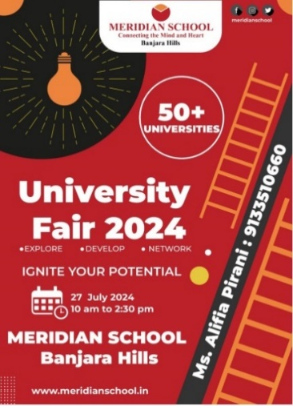

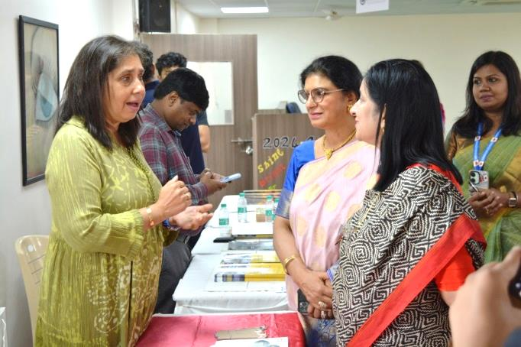

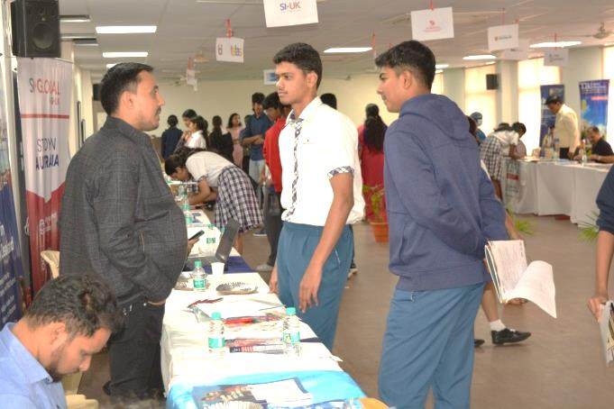
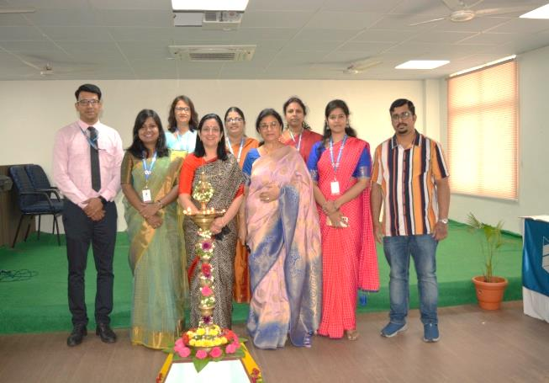

ABHIVYAKTI
YOUR TALENT! OUR STAGE!
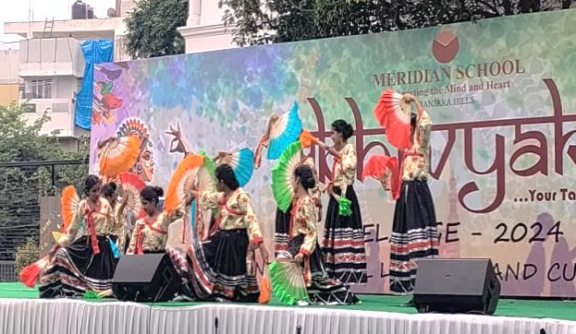
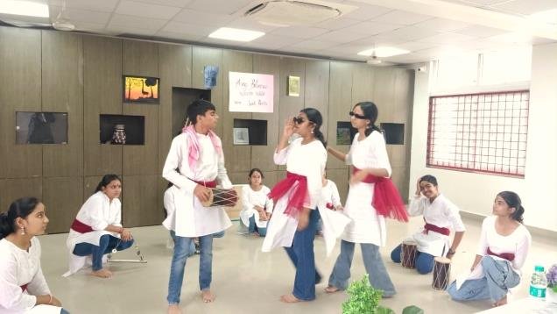

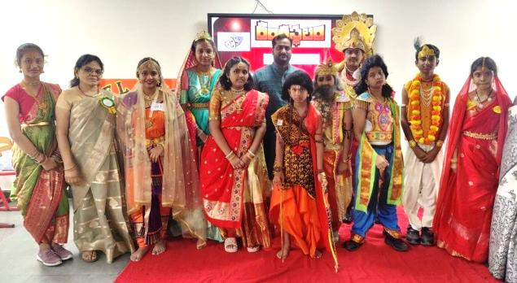

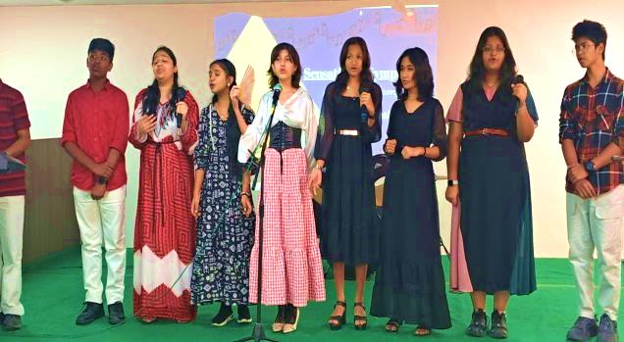

Meridian School in Banjara Hills successfully organised the much anticipated Inter-School Literary and Cultural Fest, MELANGE 2024. The event witnessed enthusiastic participation from over 20 schools, with more than 1000 participants from across the schools of Hyderabad and Secunderabad, celebrating the rich tapestry of literary and cultural talents of young minds.

MAKE IN INDIA! BUY IN INDIA!

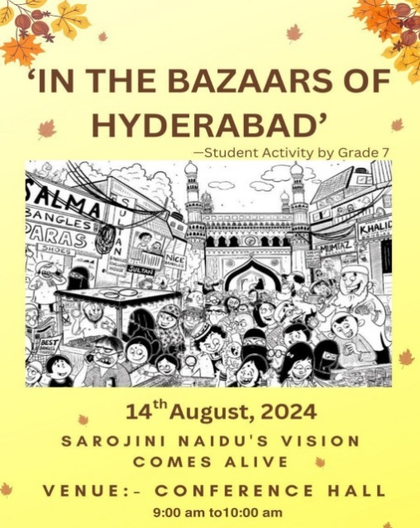

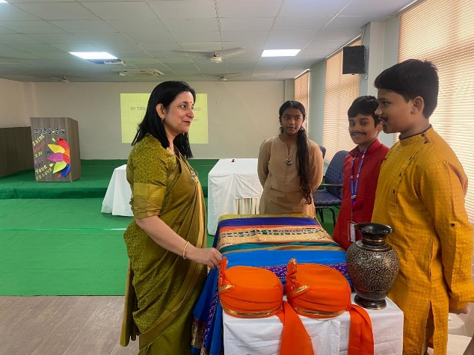

CELEBRATING THE SWADESHI MOVEMENT
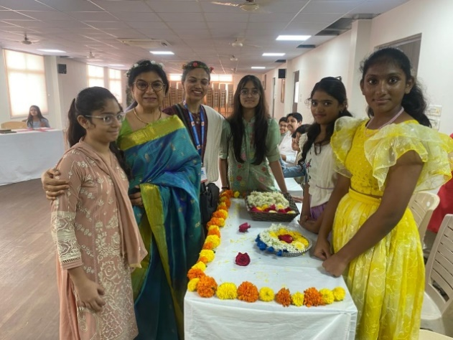
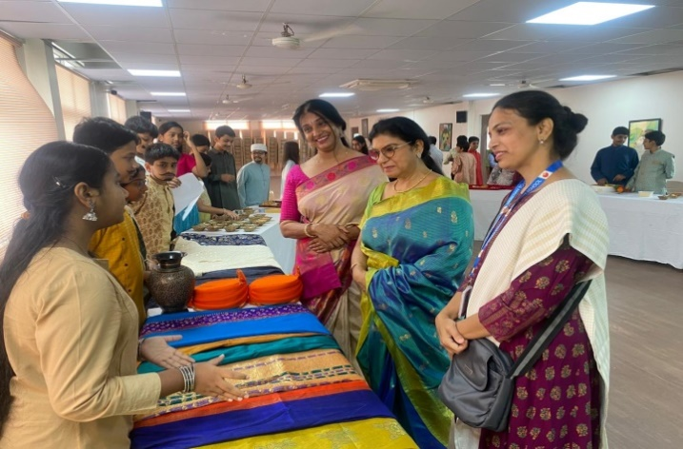

The Dept. of English, presented Sarojini Naidu's immortal poem ' In the Bazaars of Hyderabad,' by the Middle School Grade 7 students on the 14th of August.
Meridian celebrated the Nightingale of India-Sarojini Naidu's patriotism in the Independence month.
Those who love Apna Hyderabad were there !!!

LOVE FOR OUR COUNTRY!

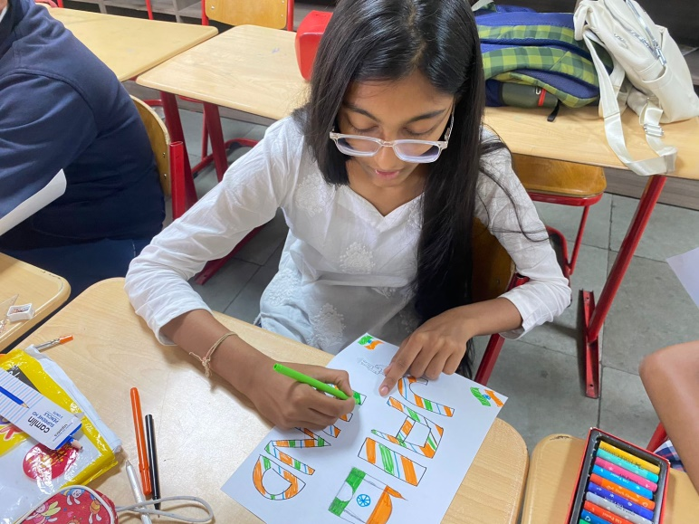
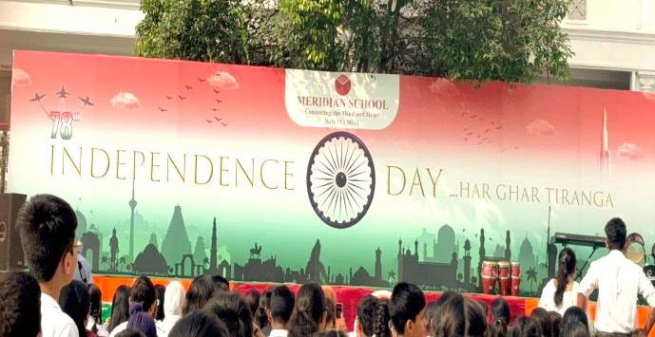

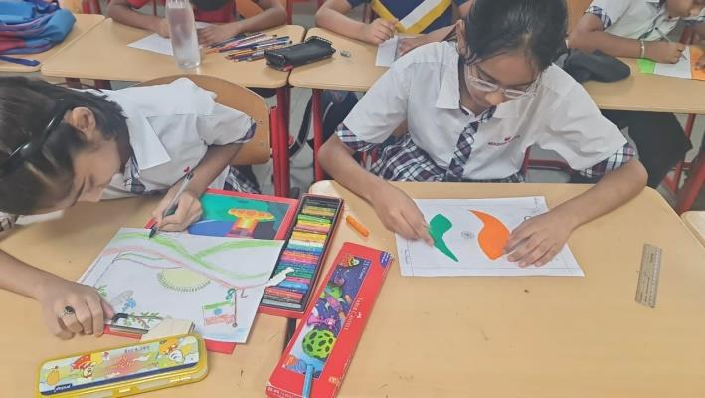



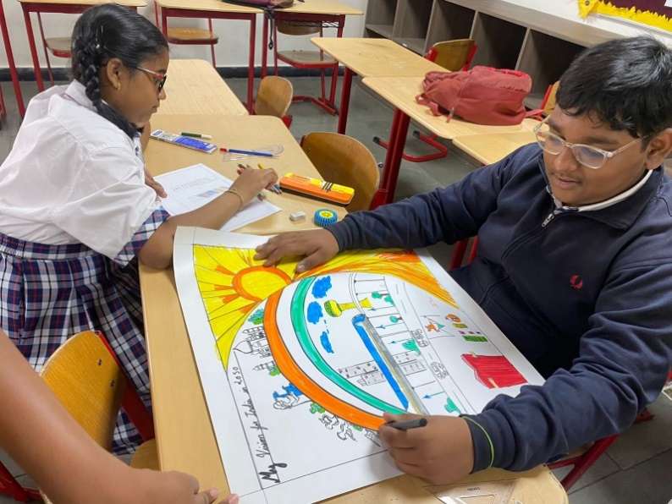

May the spirit of Freedom guide us towards a brighter future!
With this futuristic approach, Meridian School Banjara Hills celebrated the 78th Independence Day with great fervour and fanfare. After the hoisting of our National Flag, various competitions were held like Slogan Writing, Drawing, Essay Writing etc.....
The school reverberated with patriotic fervour as the students had a fun filled day!

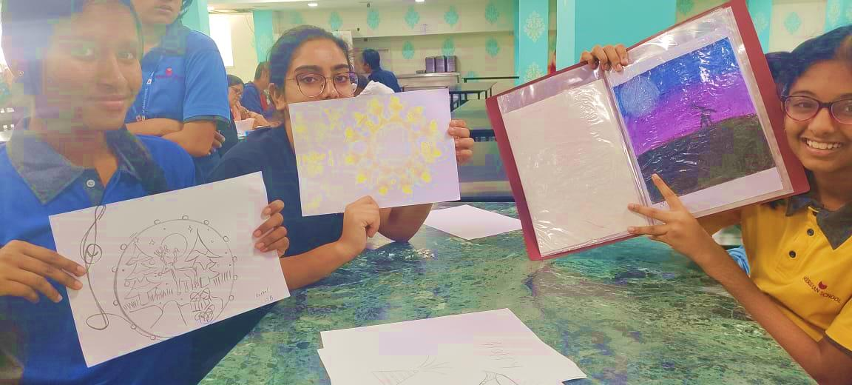
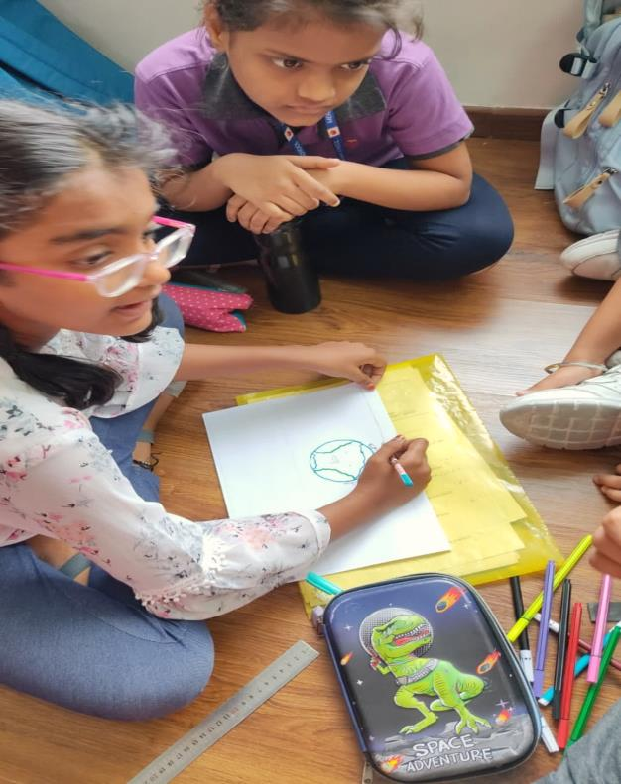

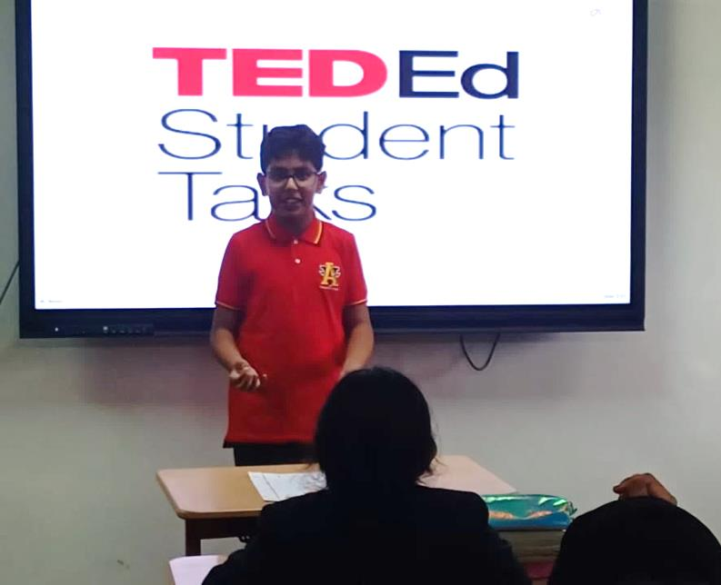
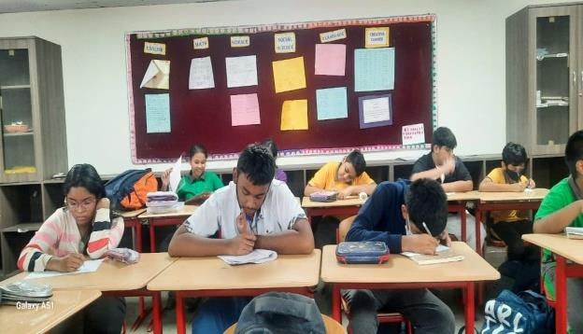

SHOWCASING STUDENT TALENT

Students eagerly participating in various club activities, including the Heritage Club, Literary Club, Ted-Ed Club, Cultural Club, Eco Club, Art Club and the Health and Wellness Club.

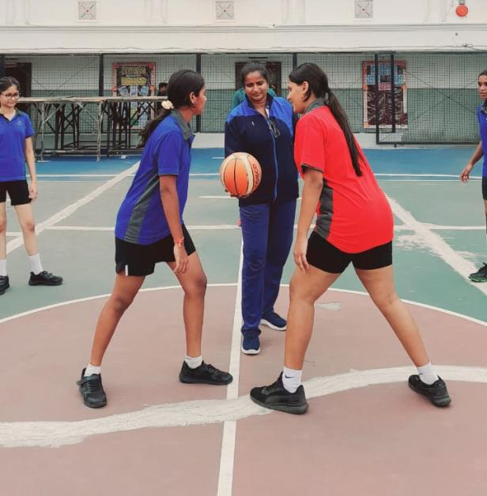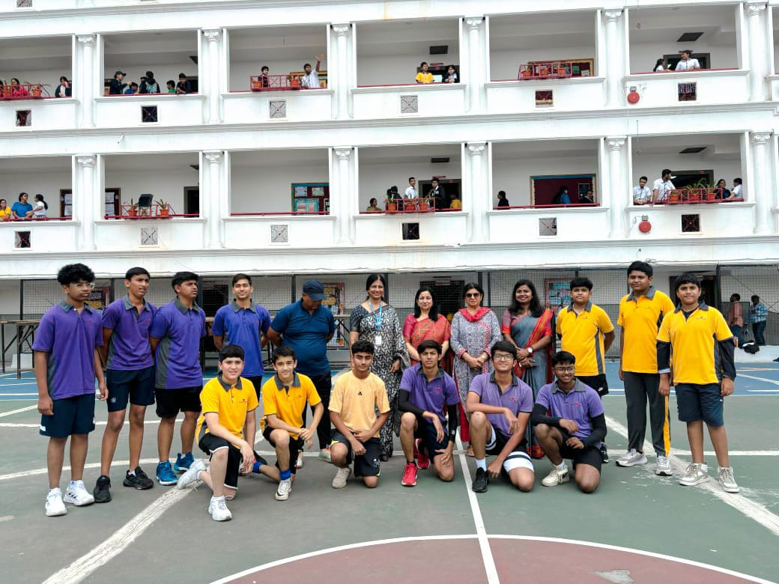
SPORTING SUCCESS!
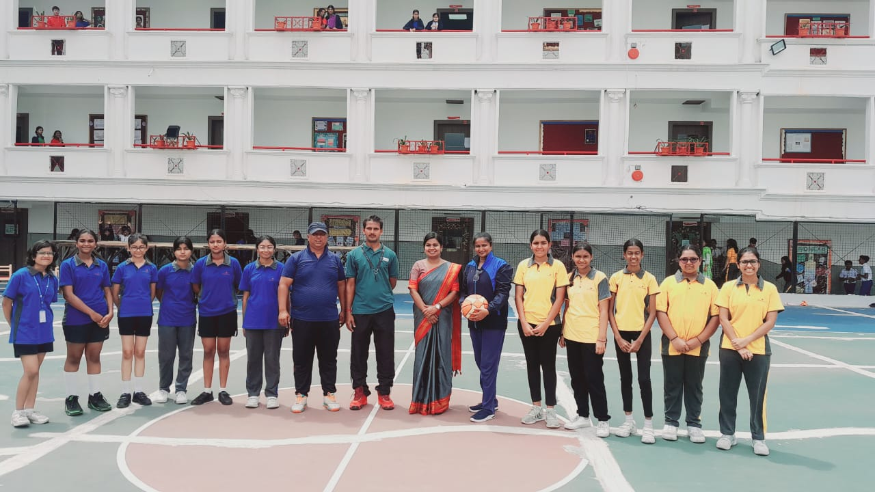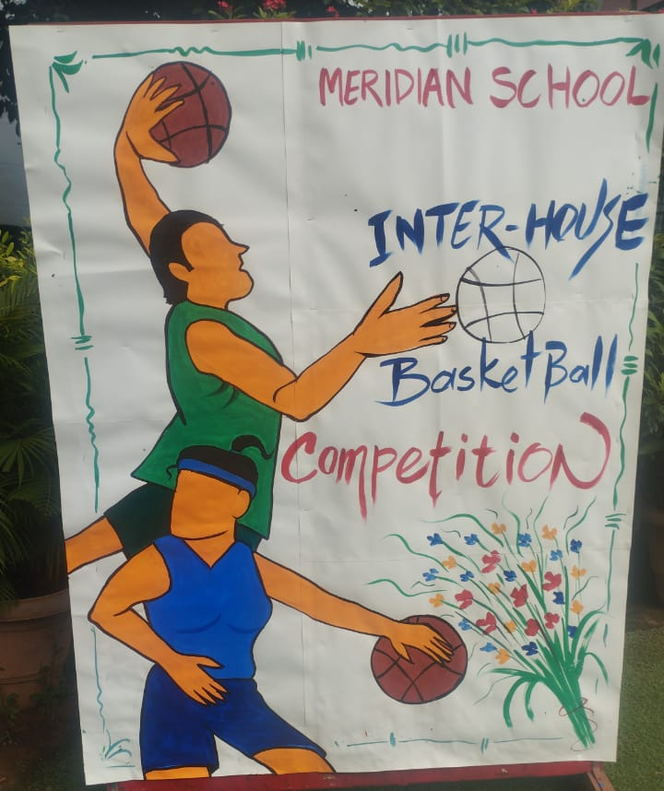

Meridian School, Banjara Hills conducted Inter-House Basketball matches to celebrate the National Sports Day.
Here are the results:
Boys Team:
Winners: Mithras Team
Runners-Up: Helios Team
Girls Team:
Winners: Amon re Team
Runners-Up: Mithras Team
Congratulations to all the teams for their outstanding performances and the Sports Department!
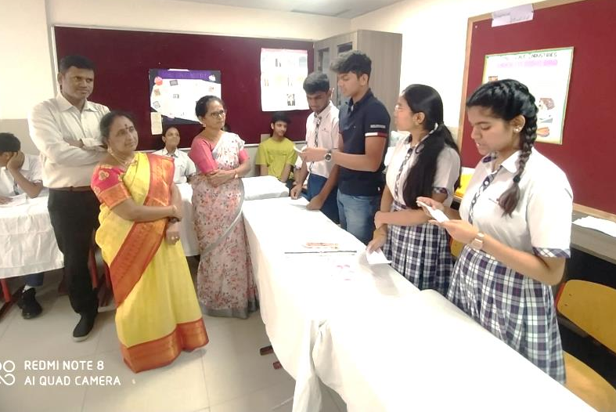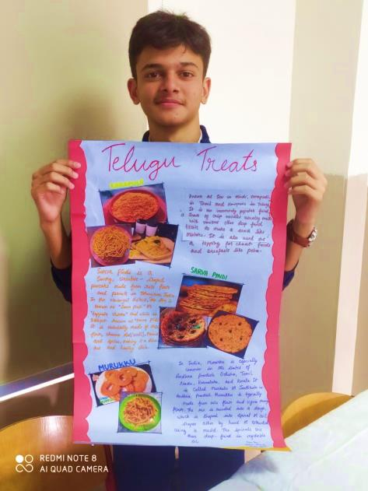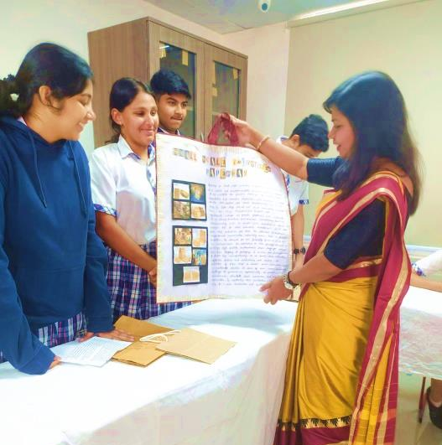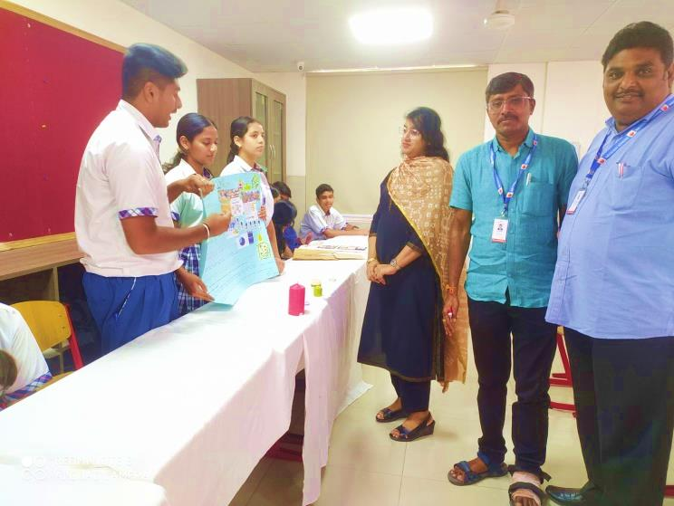
BUDDING BUSINESS ENTREPRENEURS
On 29th August 2024 students of Grade 11 organised the Small Scale Industrial Exhibition as a class activity. This SSI simulation is a valuable hands on experience and provides practical knowledge to students in running a small business from production to sale. For this activity, students were divided into small groups, with each group representing a separate small scale industry such as
1. Jute bags
2. Cupcakes
3. Rakhi making
4. Pottery
5. Candles
6. Chocolates
7. Telangana Ruchulu
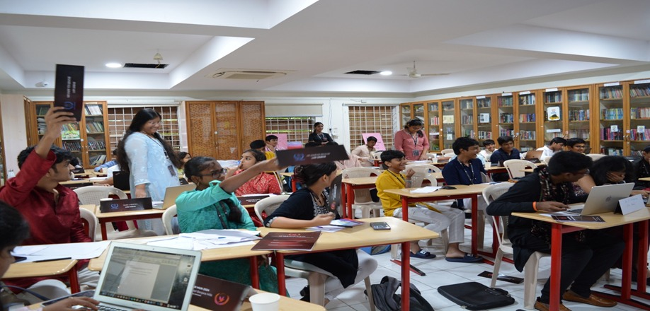
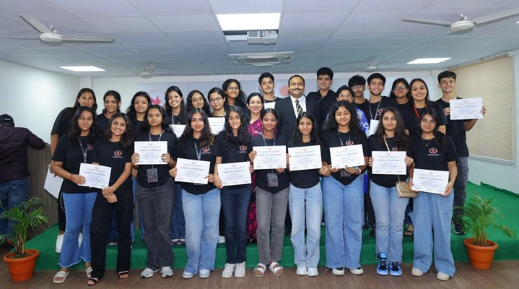
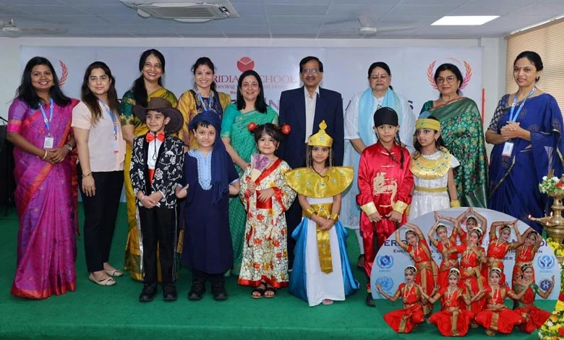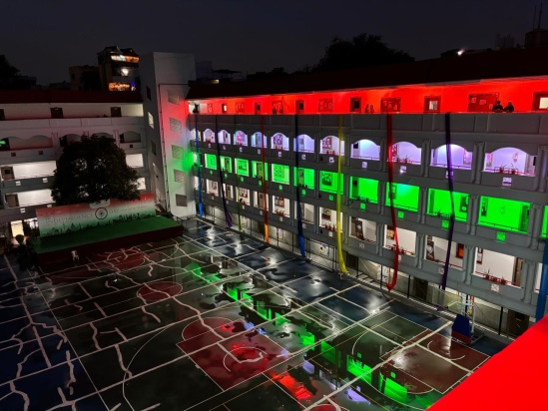

MERIDIAN MUN MAGIC!
Meridian School, Banjara Hills held a very colourful Inaugural Function for the 9th Edition of its 3-day Meridian Model United Nations extravaganza, on 30th August 2024.
The Chief Guest for the morning was the former distinguished Scientist & Asst Director of ISRO, Dr V Seshagiri Rao. He told the students about the inception of the UNO in 1945 and encouraged them to learn about the UN Sustainable Development Goals.
More than 300 delegates participated in the Meridian MUN. The Secretary General of the MUN Mr Rajas Agarwal, the Director General Mr Sandilya Srinivas, the Secretariat and the Organising Committee left no stone unturned to ensure seamless and serious discussions, debates, negotiations & resolutions.
UN values and sustainable development goals were reinforced in students and these sessions surely helped them to develop active listening, public speaking, and research skills.
Mr. Nihal Kovvali, High Court Advocate was the Chief Guest for the Closing Ceremony. His message to the student delegates was to "uphold the United Nation's Sustainable Development Goals" and to become part of the change they want to see in the world!
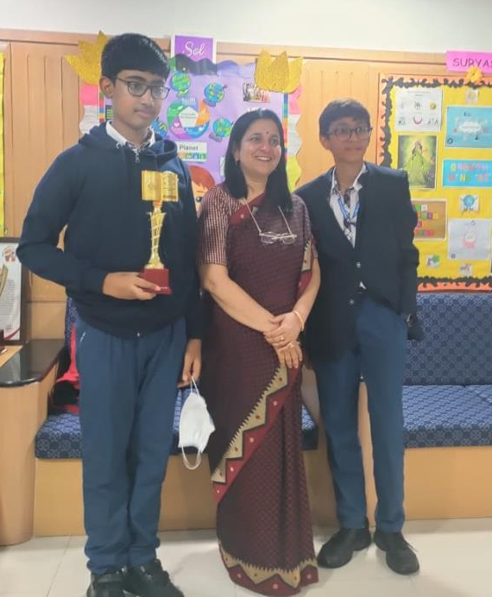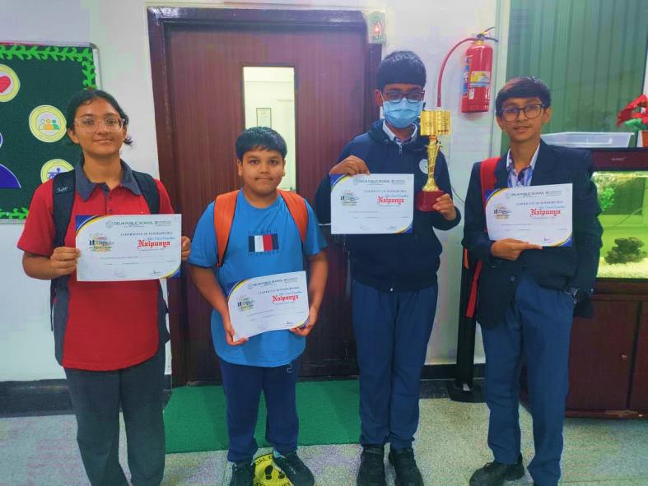
DEBATING DENIZENS!
SUCCESS SPEAKS!
Divyansh Murthy of 8D and Nivesh Bhandari of 8A secured second prize in the Turncoat Debate held at DPS, Mahendra Hills on 31/08/2024.

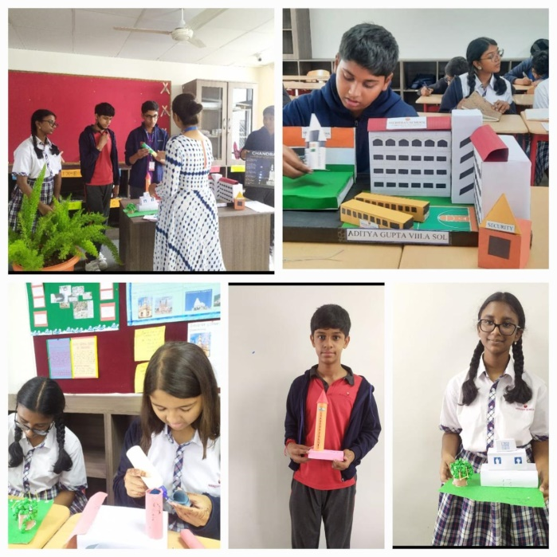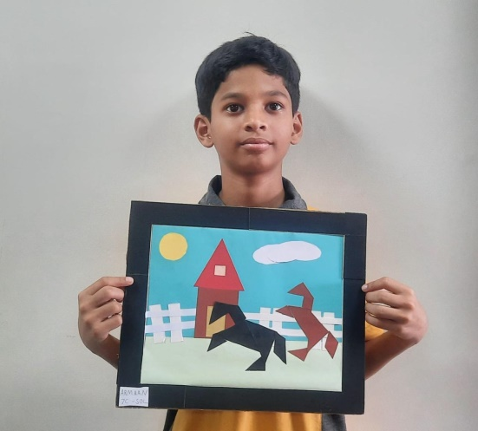

THE MAGIC OF MATHEMATICS!

‘Ganitotsav’ Math Week: Igniting Mathematical Minds
From August 21st to 23rd , students of Grades 6-8 embarked on an exciting journey of Mathematical exploration and discovery. Through a series of engaging activities and competitions, they developed a deeper understanding of Mathematical concepts, fostered teamwork, and unleashed their competitive spirits.
Highlights of the event included:
'Geometricks': A model-making competition where students brought their creativity to life using 3D and 2D shapes.
Weather Station Report: A graphical representation of real-time weather data, showcasing the practical applications of Mathematics.
'Mind Spark': A mental ability test that assessed students' speed and accuracy in Mathematical calculations, promoting mental agility and focus.
By participating in these activities, students gained valuable insights into the significance of Mathematics in everyday life, making the subject more enjoyable, accessible, and relevant.
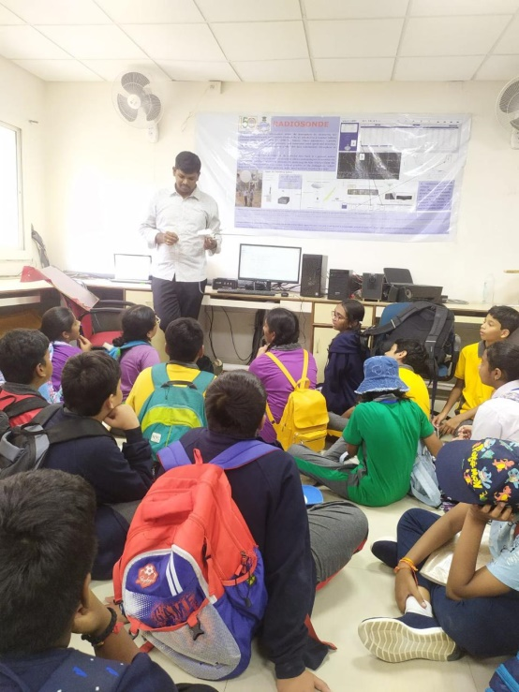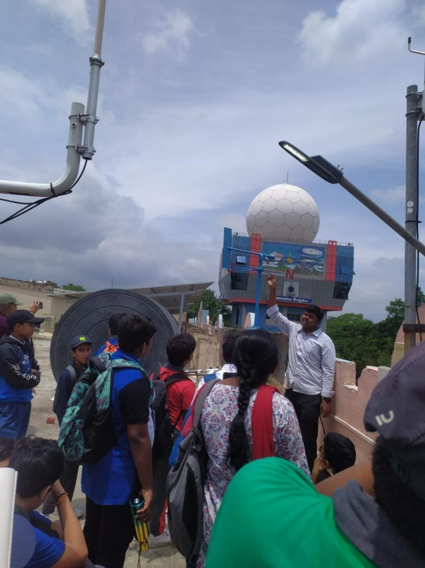
LEARNING ABOUT THE WEATHER AND CLIMATE CHANGE
On August 28, 2024 students of Grade 7 had the unique opportunity to go on a Field Trip to the Meteorological Department in Begumpet, Hyderabad. This field trip was organized to give them first-hand knowledge on how weather data is collected, analyzed, and used to forecast weather conditions that impact our daily lives.
Upon arrival, they were warmly welcomed by the department staff, who provided them with an overview of the importance of meteorology in various sectors, including agriculture, aviation, and disaster management. They were then taken on a guided tour of the facility, where students saw a variety of sophisticated instruments and technologies used to monitor the weather.
One of the highlights of the trip was visiting the weather observation deck, where they learned about the different types of equipment, such as barometers, anemometers, and rain gauges. The staff explained how these instruments measure atmospheric pressure, wind speed, and precipitation, respectively, providing essential data for weather predictions.
In the briefing room, they were shown how this data is compiled and used to create weather forecasts. The meteorologists explained the process of analyzing the data, identifying trends, and predicting future weather conditions. They also highlighted the challenges involved in making accurate forecasts, such as the variability of weather patterns and the need for timely data. The Field Trip concluded with a Q&A session, where they had the opportunity to ask questions about meteorology, weather forecasting, and the role of the department in public safety. The experts were very knowledgeable and patiently answered all the queries of our 7th Graders providing them with deeper insights into the field.
Overall, the visit to the Meteorological Department was an enlightening experience. It not only enhanced the understanding of how weather forecasts are made but also underscored the critical role that meteorology plays in our daily lives. Students left the facility with a greater appreciation for the Science behind weather predictions and the hard work of the professionals who strive to keep us informed and safe.

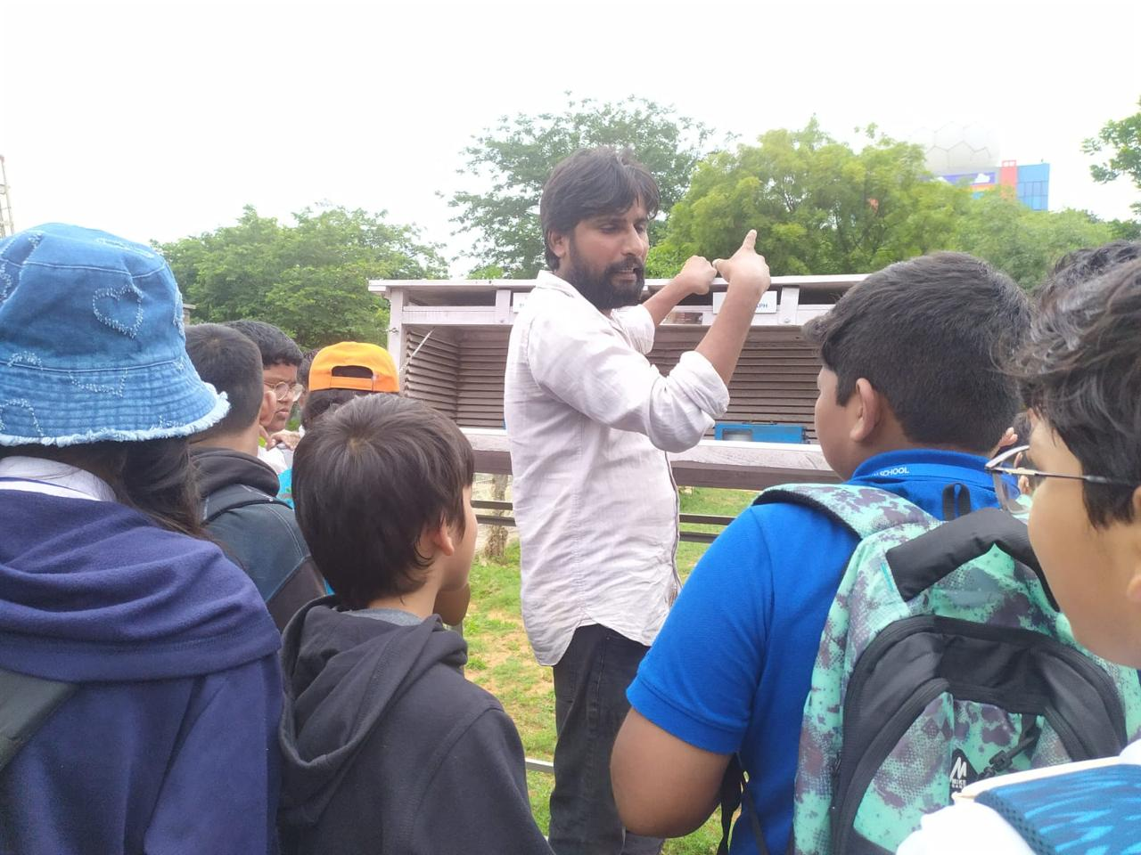

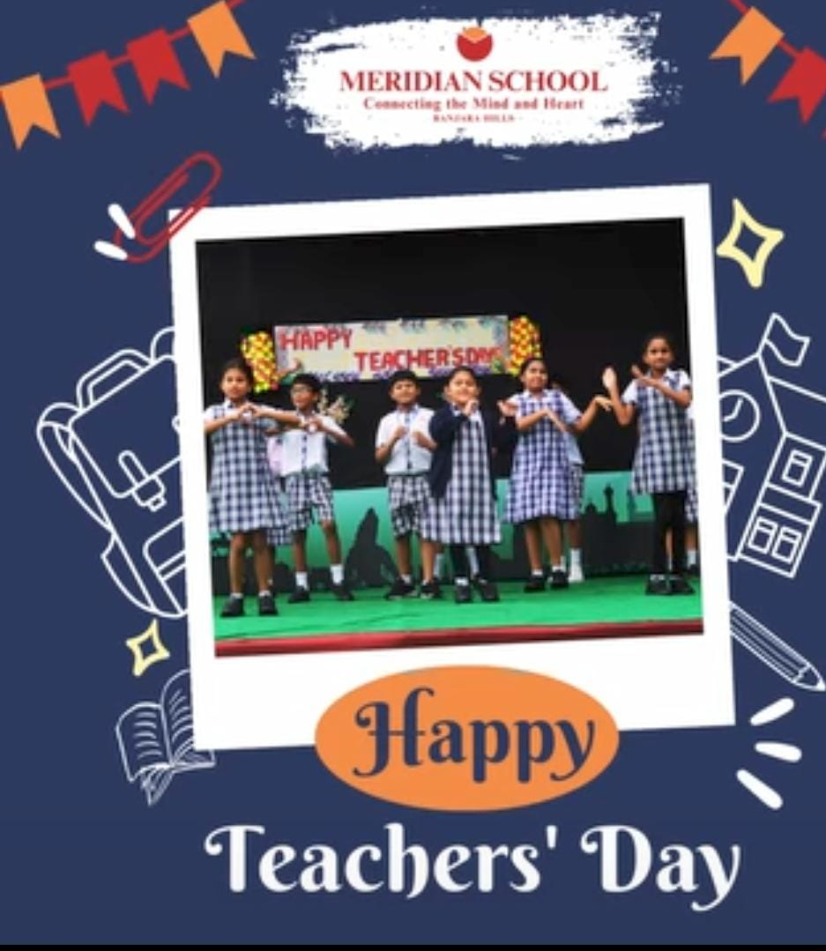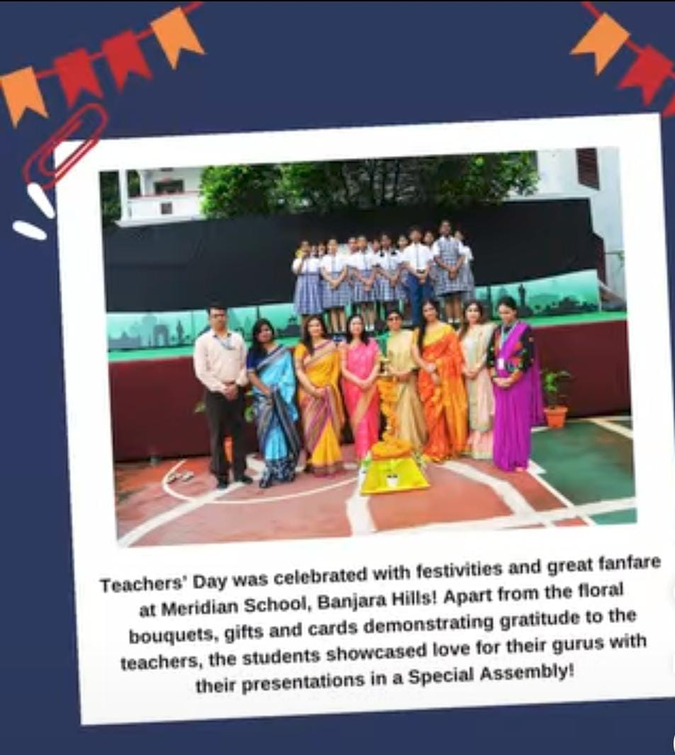

TRIBUTE TO TEACHERS!
Teachers' Day was celebrated with festivities and great fanfare at Meridian School, Banjara Hills! Apart from the floral bouquets, gifts and cards demonstrating gratitude to the teachers, the students presented a Special Tribute for their teachers through a short program with speeches, songs, dances and skits. There was fun and humour. Later the students donned the mantle of the teachers and actually conducted classes. Some gave up stating that it was a tough job.
The Principal Ms Nishi Rana in her address, congratulated and commended the teachers for their sincerity and dedication to duty ... She applauded the efforts of the students in putting up a wonderful and befitting program for their beloved teachers...

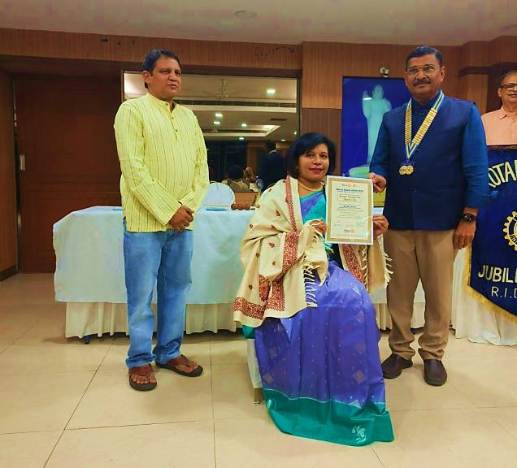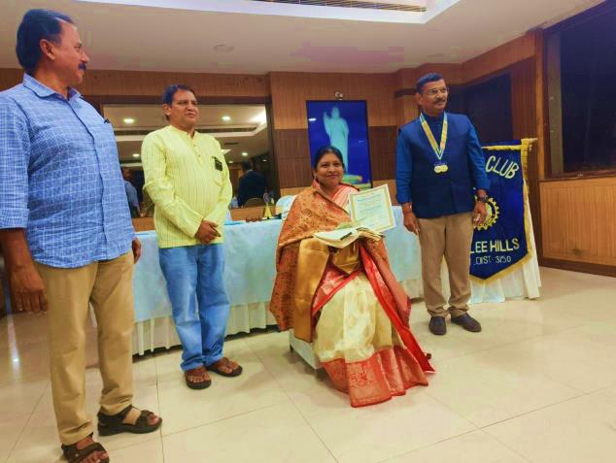
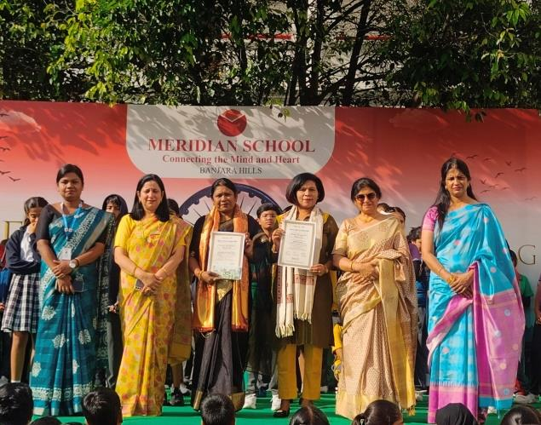
ROTARACT CLUB FELICITATES BEST CO-ORDINATORS Mrs. MARY GEORGE AND Mrs. PUSHPA RANI BABITHA- SENIOR SOCIAL SCIENCE TEACHERS FROM MERIDIAN BANJARA!
Congratulations Dear Teachers !

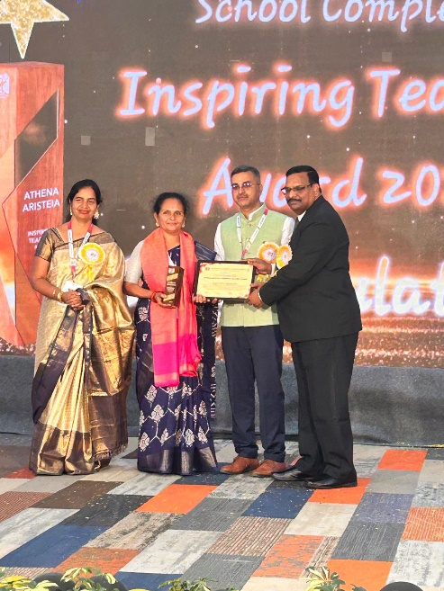

HEARTY CONGRATULATIONS TO Ms. RAJYALAXMI
ON WINNING THE ISPIRING TEACHERS AWARD 2024
By HSSC HYDERABAD SAHODAYA SCHOOLS COMPLEX

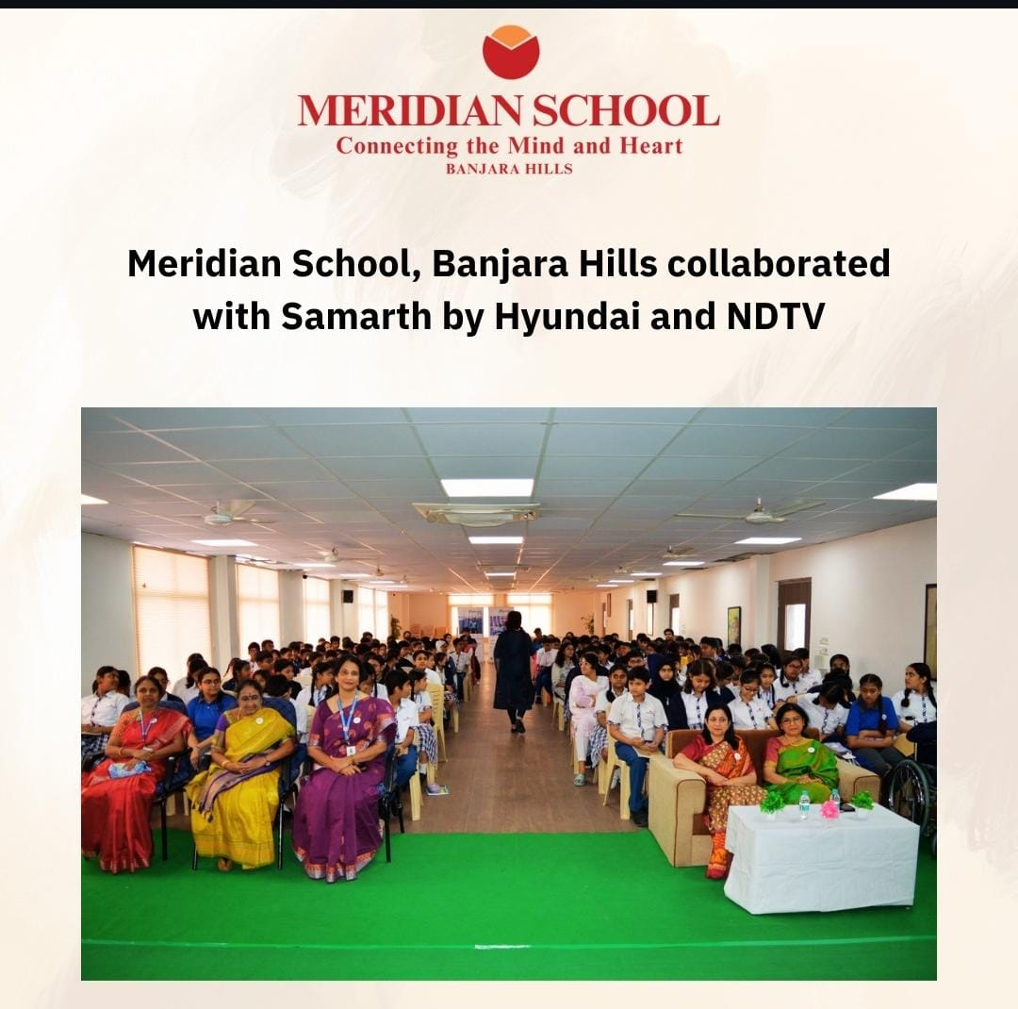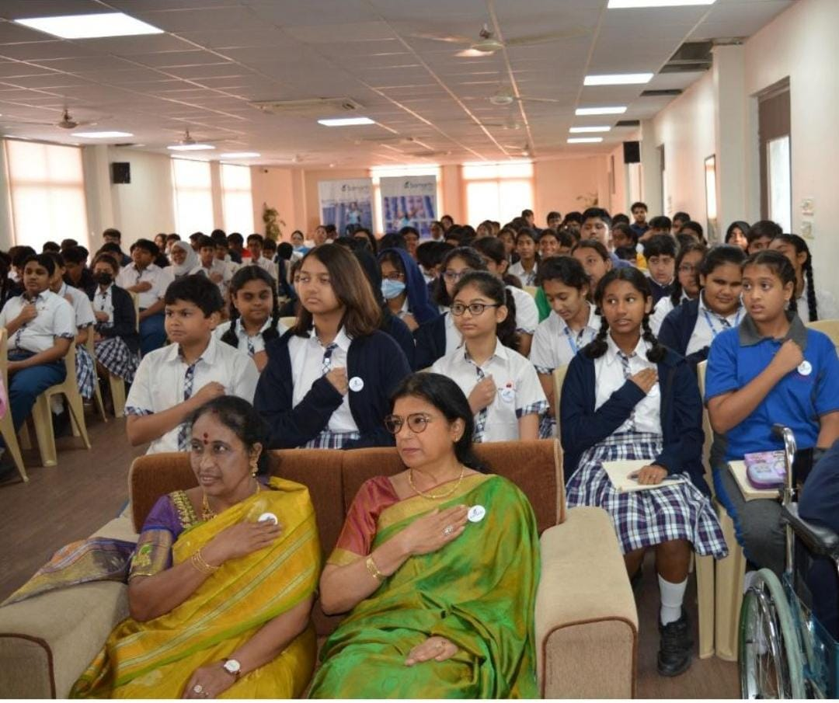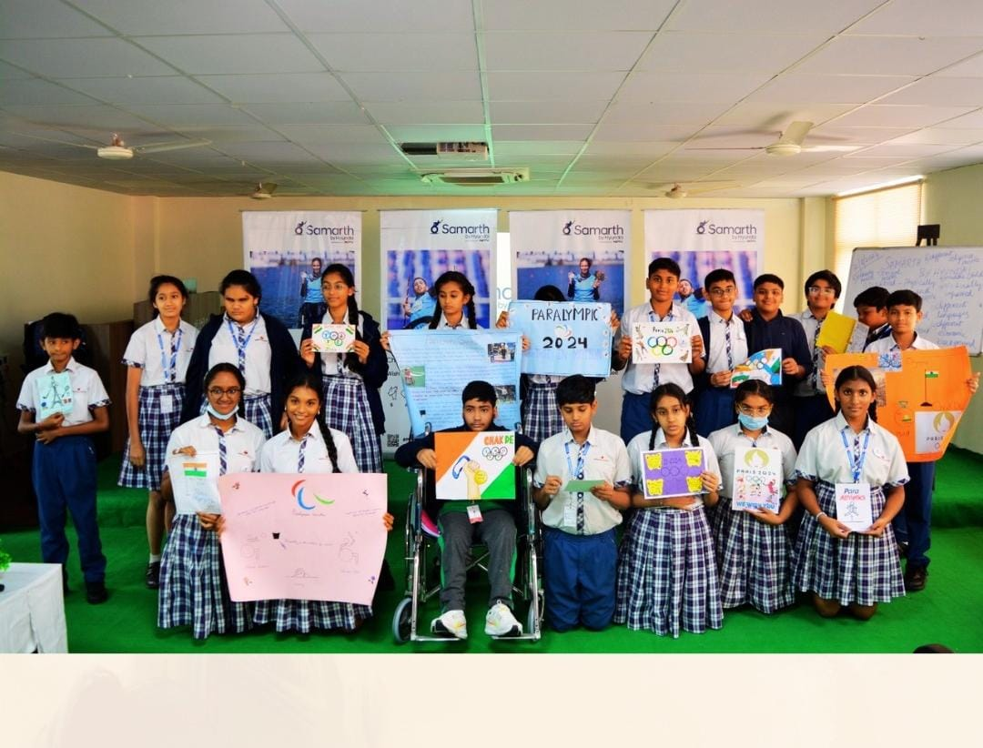
CO-OPERATIVE COLLABORATION!
MERIDIAN AND HYUNDAI PLEDGE TO ENSURE EQUAL OPPURTUNITY FOR ALL!
Meridian School, Banjara Hills collaborated with Samarth by Hyundai in an initiative to sensitise students, alter mindsets and spark larger societal change towards inclusivity. Students expressed their determination to support the differently abled and took a pledge to show compassion, empathy & ensure equal opportunities for all.
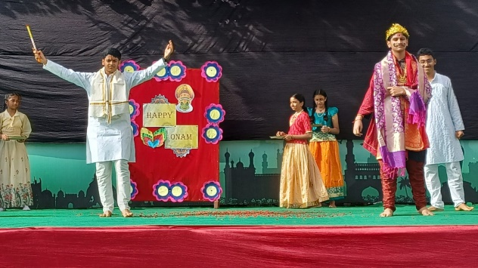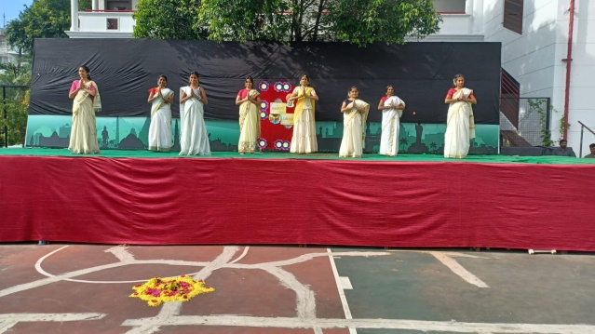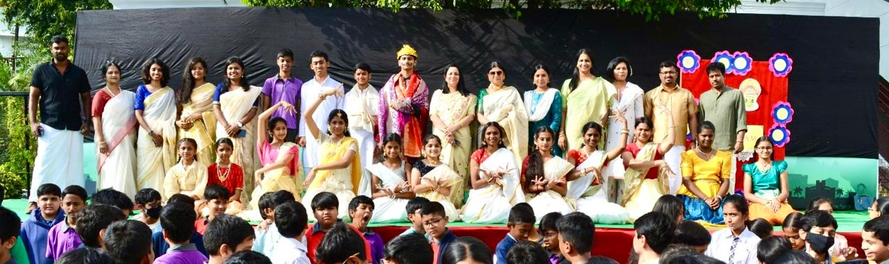
AWESOME ONAM EXCITEMENT!
The Onam celebration at school was a vibrant and joyous event. The day began with students dressed in traditional Kerala attire : girls in kasavu sarees and boys in mundu, reflecting the cultural spirit of the festival. The highlight of the celebration was the beautiful floral carpet, or pookalam, symbolizing prosperity. Various cultural performances, including Thiruvathira, a traditional dance, captivated the audience. The event brought everyone together in the true spirit of unity and festivity. The event was a delightful blend of tradition, culture, and fun, leaving everyone with cherished memories.This showcased the multicultural spirit at Meridian School, Banjara Hills.
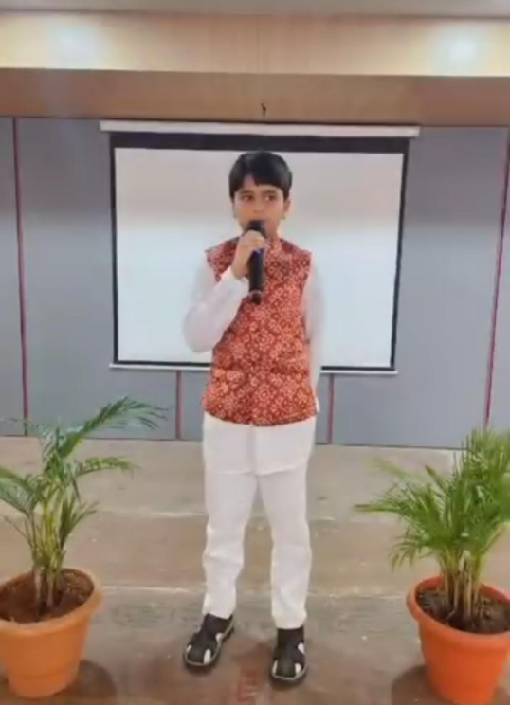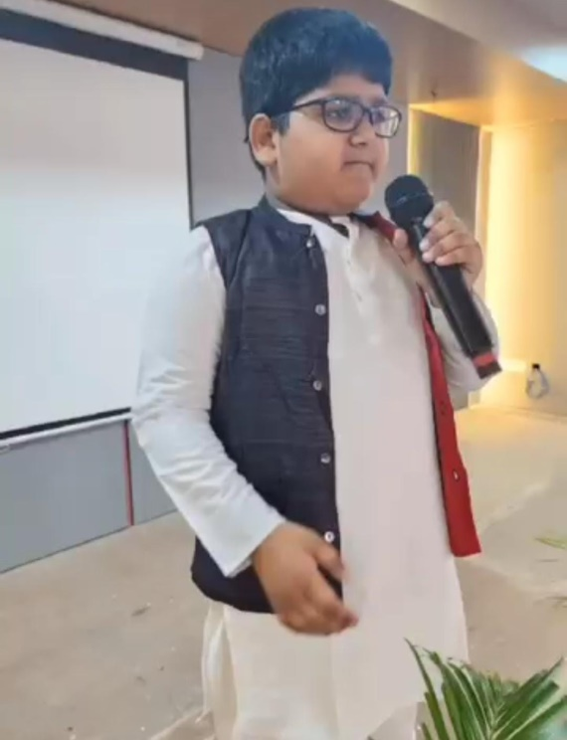

LITTLE LEADERS!
Grade 5 students organized an inspiring ‘Great Leader Competition’ at our school. This event aimed to encourage students to research, understand, and present the lives and contributions of great leaders from around the world.

On the day of the competition, the school hall was filled with excitement. Each student had prepared a presentation, which included speeches, posters, and even some creative elements like costumes and props. The diversity of leaders chosen was impressive, covering a wide array of fields such as Politics, Science, Human Rights, and Environmental Activism.

The competition was an excellent opportunity for students to develop their public speaking skills. Each participant confidently shared what they had learned, emphasizing the qualities that made their leader great.
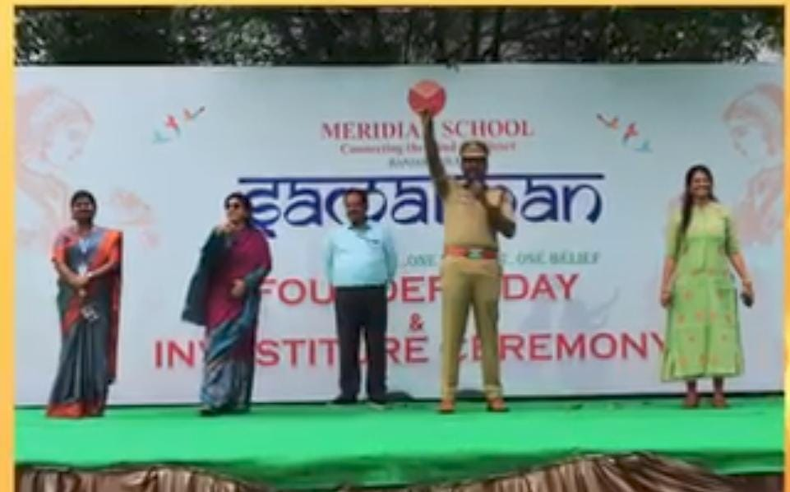

FIRE FIGHTING! UNSUNG HEROES

Students of Meridian School, Banjara Hills witnessed a Fire Safety Mock Drill.

Sub Inspector Mr. Chandra Shekhar & his Team of fire fighters from the Film Nagar Fire Station emphasised the importance of being cautious while using gas cylinders They also demonstrated the use of fire extinguishers to douse fires. The presence of a fire engine at school created a lot of excitement among the younger students.
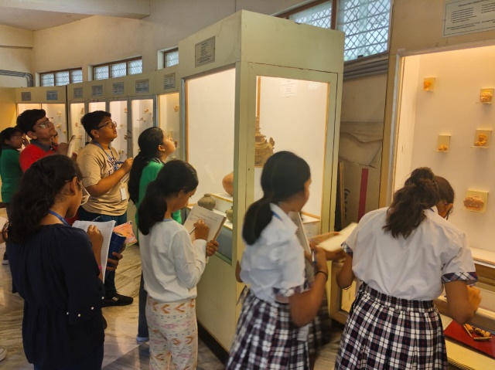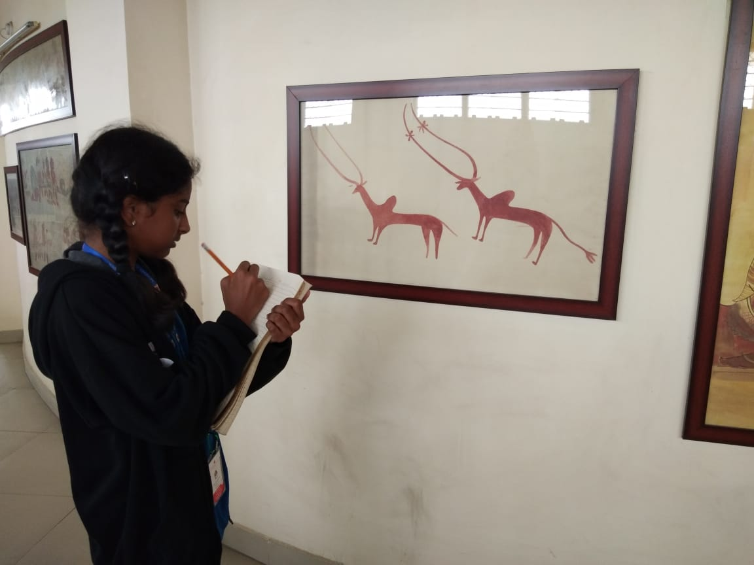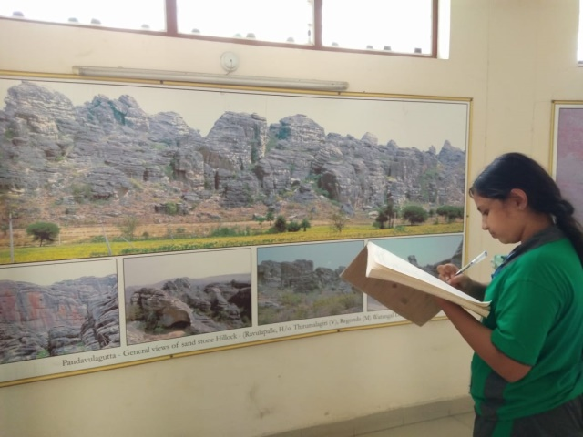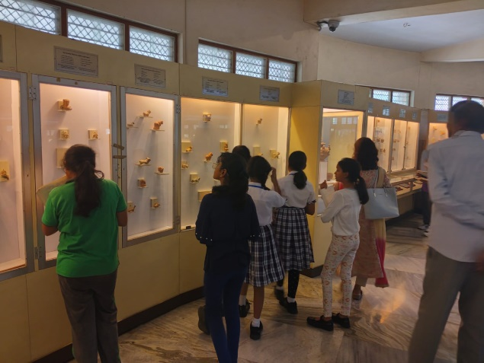
Grade 6 - Field Trip
Visit to the Centenary Heritage Museum
Students of Grade 6, Meridian School Banjara Hills embarked on an exciting Field Trip on 14/8/2024 to the Centenary Heritage Museum. They explored various exhibits that showcased the rich cultural and historical heritage of the region. The students were particularly fascinated by the ancient artifacts and interactive displays, which brought history to life. The trip provided them with a deeper understanding of their Social Science curriculum, fostering both curiosity and appreciation for the past. Overall, it was an educational and memorable experience for everyone involved.
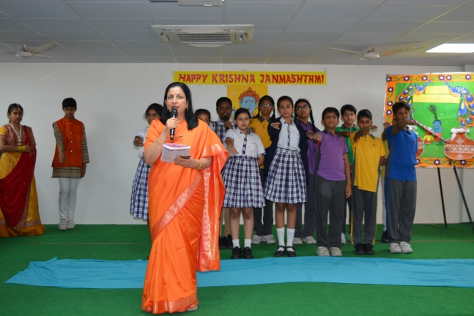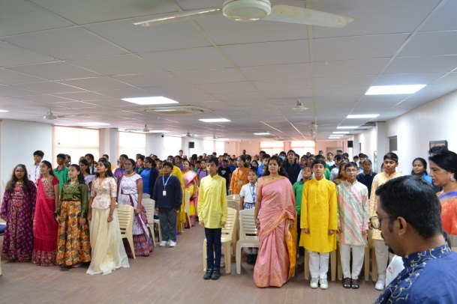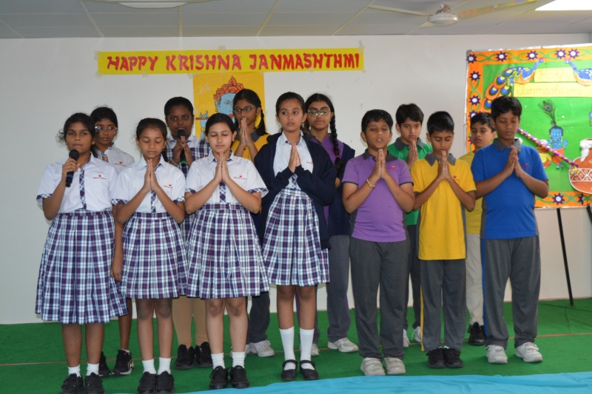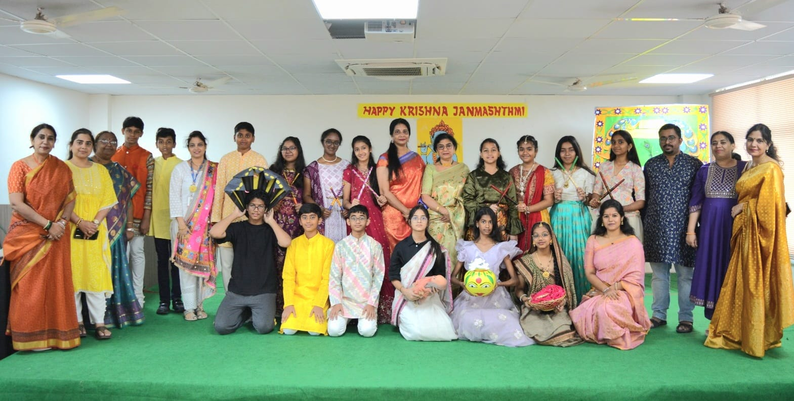

THE JOY OF JANMASHTAMI
A Special Assembly was conducted to showcase the significance of the festival.

